December 3, 2024

Dear Mr. Enrique Alberto Álvarez-Tostado Rivas,

I hope this finds you well. I am the curatorial assistant at the Johnson Museum of Art at Cornell University, and we are putting together an exhibition catalogue of our previous exhibition Guadalupe Maravilla: Armonía de la Esfera, co-curated by Rodrigo Guzman-Serrano and Jessica Levin Martinez. The exhibition, on view from January 27–June 9, 2024, showed the breadth of Maravilla’s multifaceted artistic practice, which is grounded in activism and healing, connecting ancestral knowledge and traditions with contemporary practices and concerns such as immigration, illness, and trauma.

In the catalogue, then, there will be an essay about illness and recovery in the work of Maravilla, which will include several examples of ex-votos as figural illustrations. As a key example in the essay, we graciously request to reproduce an image of the ex-voto Virgen de la Caridad, in the INAH’s collection
(MID 91_20190811-114800:311), held at the Museum of El Carmen. See below details of the publication, for your consideration:

Publication title: Guadalupe Maravilla: Armonía de la Esfera
Print run: 500-1000
Format: Print book, paperback
Publisher: Herbert F. Johnson Museum of Art

Please don’t hesitate to reach out with further questions concerning the publication, and we would be honored if you allow us to include your ex-voto image in this important new scholarship on the contemporary artist Guadalupe Maravilla. We send our best wishes and gratitude in advance.

Sincerely,

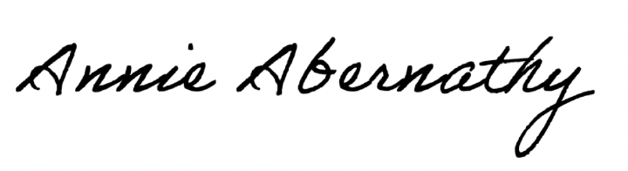
Annie Abernathy
Curatorial Assistant

